5.AIM:-To implement UML diagrams for ONLINE COURSE RESERVATION SYSTEM…

1.COLLABORATION DIAGRAM:-

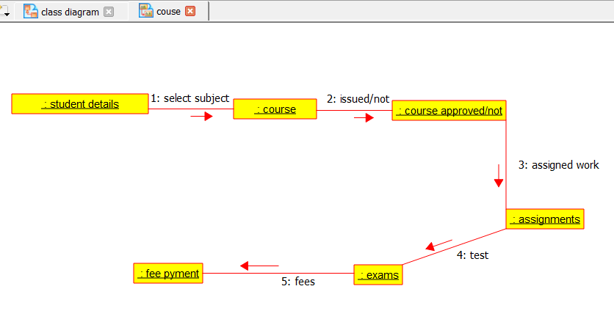

2.USECASE DIAGRAM:-

